1. Core Principles
- Single Responsibility → Each service should do one business capability well (e.g., Order Service, Inventory Service, Payment Service).
- Loose Coupling → Services should be independent. Changing one should not break others.
- High Cohesion → Each service owns its logic + database.
- Autonomous Teams → Services can be developed, deployed, and scaled independently.

2. Service Boundaries
- How to split? (DDD helps — Domain Driven Design)
  - By business domain (Order, Cart, Catalog, Shipping).
  - Avoid splitting just by technical layers (like “DAO Service,” “Controller Service”).

3. Data Management
- Each service owns its own database (no shared tables).
- Patterns:
  - Database per service (recommended).
  - Polyglot persistence (different DB types for different needs).
  - Event sourcing & CQRS if strong consistency or read/write separation is needed.

4. Communication
- Sync (Request/Response) → REST, gRPC, GraphQL.
- Async (Event-driven) → Kafka, RabbitMQ, Azure Service Bus.
- Pick sync for real-time needs and async for eventual consistency & decoupling.

5. Resiliency
- Failures are inevitable → handle them!
  - Circuit Breaker (e.g., Netflix Hystrix, Polly in .NET).
  - Retries + Timeouts.
  - Bulkhead & Rate Limiting.
  - Idempotency in APIs to avoid duplicate processing.

6. Transactions Across Services
- Distributed transactions are hard.
- Use Sagas (Choreography or Orchestration) instead of 2-phase commit.
- Compensating transactions for rollback.

7. API Gateway
- Single entry point → hides internal services.
- Responsibilities:
  - Routing
  - Authentication & Authorization
  - Rate limiting
  - Aggregation (combine responses from multiple services).

8. Security
- OAuth2 / OpenID Connect / JWT for authentication.
- Zero-trust approach → Don’t assume “internal network is safe.”
- Encrypt communication (HTTPS everywhere).

9. Observability
- Harder than monoliths → you need:
  - Centralized Logging (ELK, Azure App Insights, Grafana Loki).
  - Metrics & Monitoring (Prometheus, Grafana).
  - Distributed Tracing (Jaeger, OpenTelemetry, Application Insights).

10. Deployment & Scaling
- Services can be deployed independently.
- Use containers (Docker) + orchestration (Kubernetes, Azure AKS, AWS ECS).
- Scale each service based on its own demand.

11. Testing Strategies
- Unit testing per service.
- Contract testing (Pact) to ensure APIs don’t break others.
- Integration testing + end-to-end flows.

12. Team & Organizational Impact
- Conway’s Law → architecture reflects team structure.
- Microservices work best with small, autonomous teams (2–8 people).
- Each team owns design → deploy → maintain.

Q What is Event Sourcing?
Event Sourcing is a pattern where the state of a system (or entity) is not stored as the latest snapshot in a database table.
Instead, it is stored as a sequence of events that happened in the past.
👉 You don’t just save “current state”, you save “everything that happened to reach that state.”
Let’s say you have an Order microservice.
- In a traditional system (CRUD style), you’d store the current order row in a table:
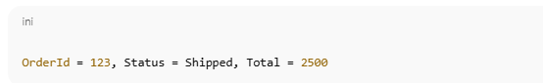

In Event Sourcing, you’d store events like:
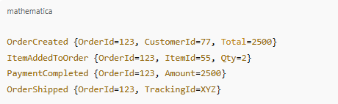
To know the current state of the order, you replay events in sequence.
🔹 Why Use Event Sourcing?
- Auditability → You know exactly what happened and when (like a ledger in banking).
- Debugging & Replay → You can replay events to rebuild the system state.
- Scalability → Events can be published to other services (e.g., Shipping, Notification).
- Temporal Queries → You can ask “What was the order state last week?”

🔹 Challenges of Event Sourcing
- Complexity → You must reconstruct state from events.
- Event Versioning → Schema changes require handling old event formats.

Event Store → You need special storage (EventStoreDB, Kafka, CosmosDB, SQL with append-only log).
🔹 Technical Implementation (Microservices + .NET Example)

1. Domain Events

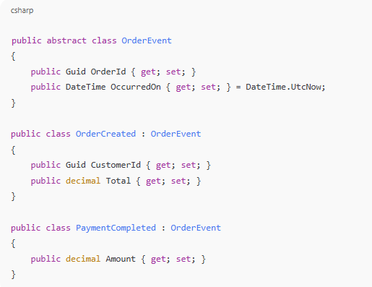
2. Event Store Repository

Instead of saving Order directly in SQL:
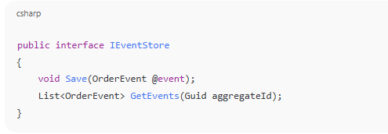
3. Rebuilding State
The Order entity is rebuilt by replaying events:
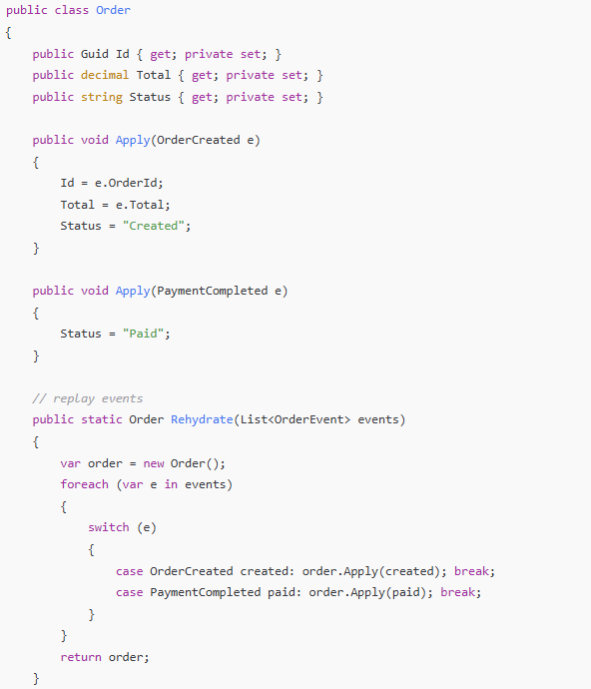

4. Integration with Other Microservices
- When OrderCreated is saved, it can also be published to a message broker (Kafka, RabbitMQ, Azure Service Bus).
- Other services (e.g., Inventory Service) subscribe and react.

In short
- CRUD style: Save final state.
- Event Sourcing style: Save all changes (events) → Rebuild state when needed.

